|  |  |
| --- | --- |
| **YEAR 8** | **Light Energy** |

|  |  |
| --- | --- |
| **Learning Intentions** | **Success Criteria** |
| Understand light energy. | * Describe light energy. * Give examples of sources of light. * Compare luminous and non-luminous objects. * Compare transparent, translucent & opaque objects. * Explain how shadows are created. * Describe visible light energy. * Assess the energy efficiency of different light bulbs. |

**READ:** *Light Energy* **Light**is a form of energy that enables us to see all the things around us but did you know there is also light energy that humans can’t see too, such as infrared and ultraviolet. Unlike sound, light energy can travel without matter. This means it can move easily through space. The main source of light on the Earth is the sun.

**ACTIVITY 1:** *Light on Scholastic*

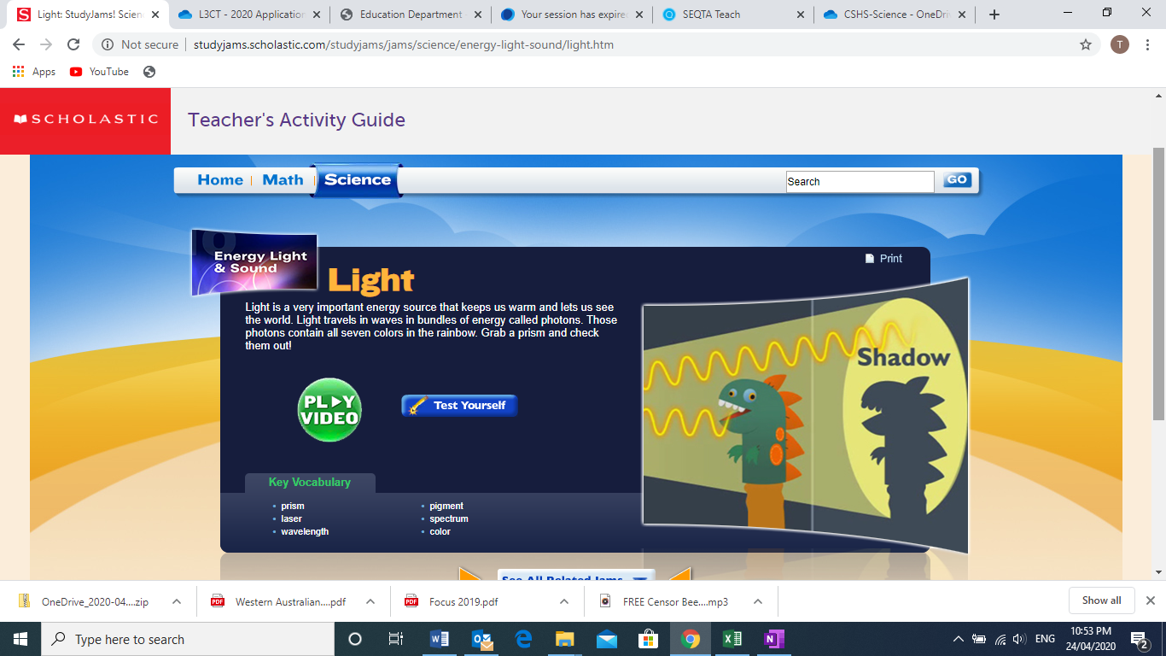

**Image:** <http://studyjams.scholastic.com/studyjams/jams/science/energy-light-sound/light.htm>

**YOUR TASK:**

1. GO TO: <http://studyjams.scholastic.com/studyjams/jams/science/energy-light-sound/light.htm>
2. Watch the video about light from “Scholastic Study Jams”
3. Complete the “Test Yourself” activity provided.

**WATCH:** *What is Light?*

|  |  |
| --- | --- |
| File:Logo of YouTube (2015-2017).svg - Wikipedia | Watch this YouTube video:  <https://www.youtube.com/watch?v=d7yTlp4gBTI&t=62s> |

**ACTIVITY 2:** *Light Ray*

GO TO: <http://www.scootle.edu.au/ec/viewing/L2041/index.html>

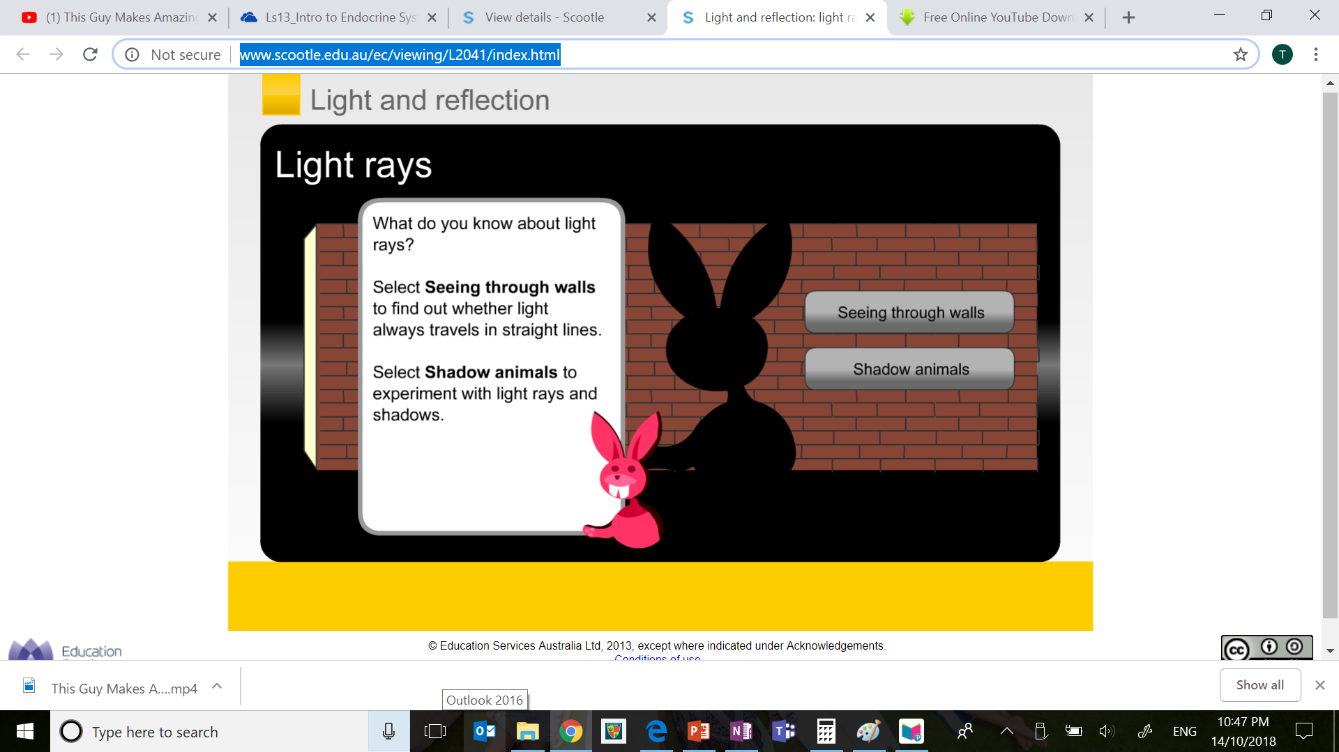

Image: <http://www.scootle.edu.au/ec/viewing/L2041/index.html>

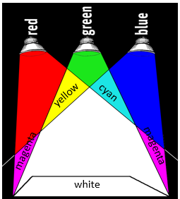 **READ:** *Visible Light Energy*

White light, like sunlight, is a mixture of many different colours, each with a different frequency.

Each individual colour of light has a different **wavelength** and **frequency**. Red light has the longest wavelength and slowest frequency, whereas violet light has the shortest wavelength and highest frequency.

https://www.exploratorium.edu/snacks/colored-shadows

**ACTIVITY 3:** *Creating Rainbows*

**Purpose:** To observe that white light being split into all of the colours of the rainbow.

**Your task:**

1. For this investigation, you will need to experiment with all of the shapes in your kit.
2. Position your light beam so that it enters the shapes at different angles.
3. Your goal is to create a rainbow.

**What You Need:**

* A glass of water
* A sheet of white paper
* A sunny day or a flashlight

**Instructions:**

1. Fill the glass almost to the top with water.
2. If you are using sunlight, place the glass so that it is half on and half off the edge of a table, and so that the sun shines directly through the water, onto a sheet of white paper on the floor.
3. Adjust the paper and the glass until a rainbow forms on the paper.
4. If you are using a flashlight, place the glass of water on the white piece of paper, and move the flashlight around until you see a rainbow on the piece of paper

**Results:** Draw a labelled diagram of how you created your rainbow.

|  |
| --- |
|  |

**ACTIVITY 4:** *Reflecting Light*

GO TO: <http://www.scootle.edu.au/ec/viewing/L2042/index.html>

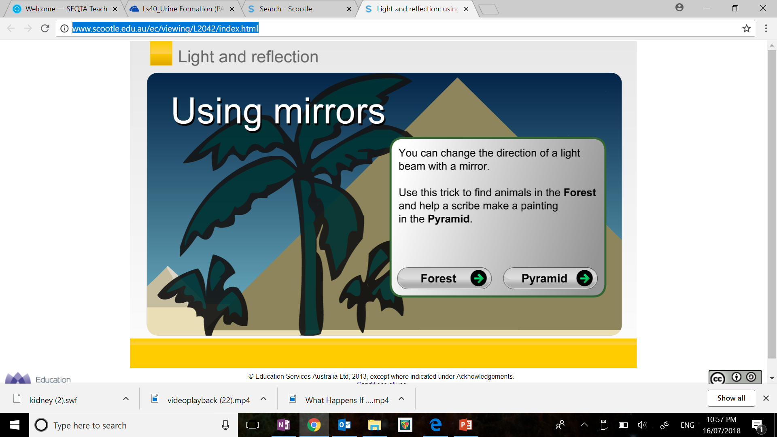

Image: <http://www.scootle.edu.au/ec/viewing/L2042/index.html>

**ACTIVITY 5:** *Reflecting Light*

GO TO: <http://www.scootle.edu.au/ec/viewing/L2043/index.html>

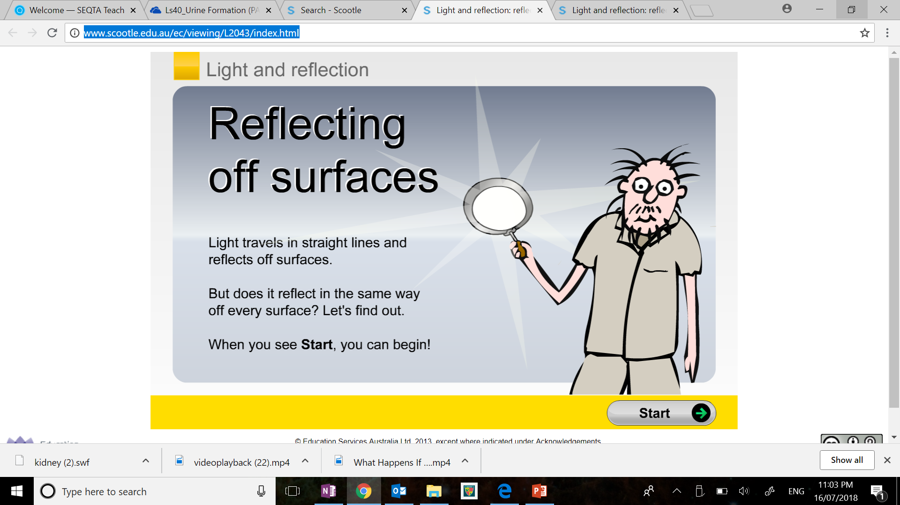

**Image:** <http://www.scootle.edu.au/ec/viewing/L2043/index.html>

**ACTIVITY 6:** *Energy Efficient Light Bulbs*

You may have noticed that there are different types of light bulbs. Some light bulbs are more energy efficient than others. This means that more of their output energy is light energy and less is wasted as heat energy.

|  |  |  |  |
| --- | --- | --- | --- |
| LED vs Halogen, CFL, or Tungsten: Which Bulbs Are Better ... | Difference between light bulbs such as CFL, LED, Halogens and ... | Difference between light bulbs such as CFL, LED, Halogens and ... | Difference between light bulbs such as CFL, LED, Halogens and ... |
| **Traditional Incandescent** | **Halogen Incandescent** | **Compact Fluorescent (CFL)** | **Light Emitting Diodes (LED)** |

https://bchsgroup.com/difference-various-light-bulbs-cfl-led-halogens-incandescent/

**YOUR TASK:** Investigate the three different types of light bulbs shown below.

1. Compare the positive and negative of each light bulb including their energy efficacy.

|  |  |  |  |
| --- | --- | --- | --- |
| **Light Bulb** | **Positives** | **Negatives** | **Energy Efficiency** |
| **Traditional Incandescent** |  |  |  |
| **Halogen Incandescent** |  |  |  |
| **Compact Fluorescent (CFL)** |  |  |  |
| **Light Emitting Diodes (LED)** |  |  |  |

1. Make an argument for which light bulbs people should use in their house.

|  |
| --- |
|  |

1. Make an assessment of the lights used in your home. With reference to light energy, how efficient is your home? Explain.

|  |
| --- |
|  |

**END OF WEEK TEST:** *Light**Energy*  
 **Question 1**

1. True or false: light waves require matter to travel. ________________
2. Describe the difference between transparent, translucent & opaque objects.

|  |
| --- |
| Transparent |
| Translucent |
| Opaque |

1. What does it mean if an object is luminous? Give an example.  
     
   ________________________________________________________________________
2. What does it mean if an object is non-luminous? Give an example.  
     
   ________________________________________________________________________
3. What might humans experience the frequency of light as? ________________________
4. In visible light, high frequency light waves are usually what colour? _________________
5. In visible light, low frequency light waves are usually what colour? __________________

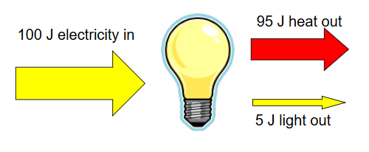 **Question 2**

Assess the energy input and output of the   
lightbulb shown. Would you recommend   
someone use this light bulb? Explain why or   
why not.

https://slideplayer.com/slide/10638938/

|  |
| --- |
|  |
|  |
|  |
|  |

Rate your understanding of heat (thermal) energy:  
 